**#1.Given a list of numbers, find the sum and average**

num=input()

num_list=list(map(int,num.split()))

count=0

for i in num_list:

count+=i

avg=count/len(num_list)

print("sum is: ",count)

print("average is: ",avg)

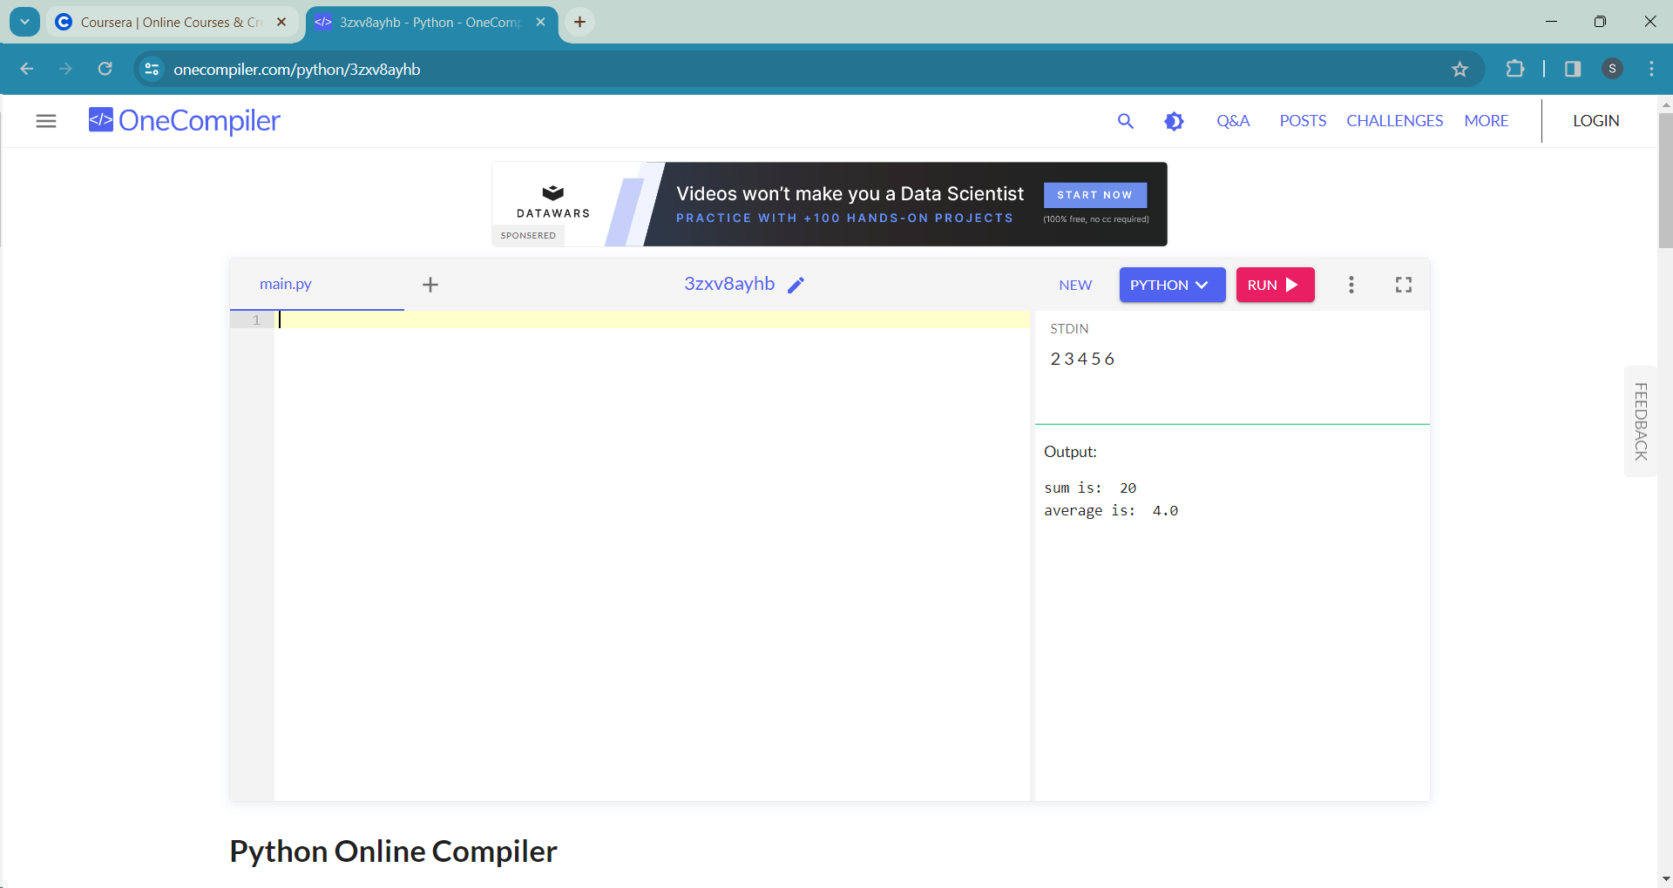

**#2. Create a program that takes a temperature in Celsius and converts it to Kelvin**

celsius=int(input())

kelvin=celsius+273

print("The temperature in kelvin is: ",kelvin,"K")

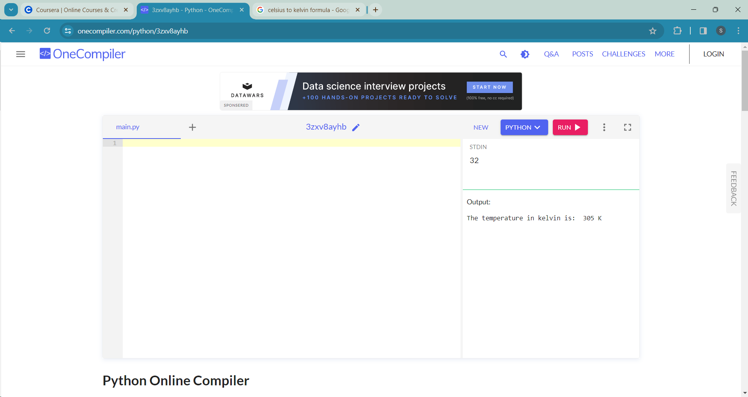

**#3.Implement a program that checks if a given string is a palindrome**

n=str(input())

if n==n[::-1]:

print("yes, it's a palindrome")

else:

print("no, it's not a palindrome")

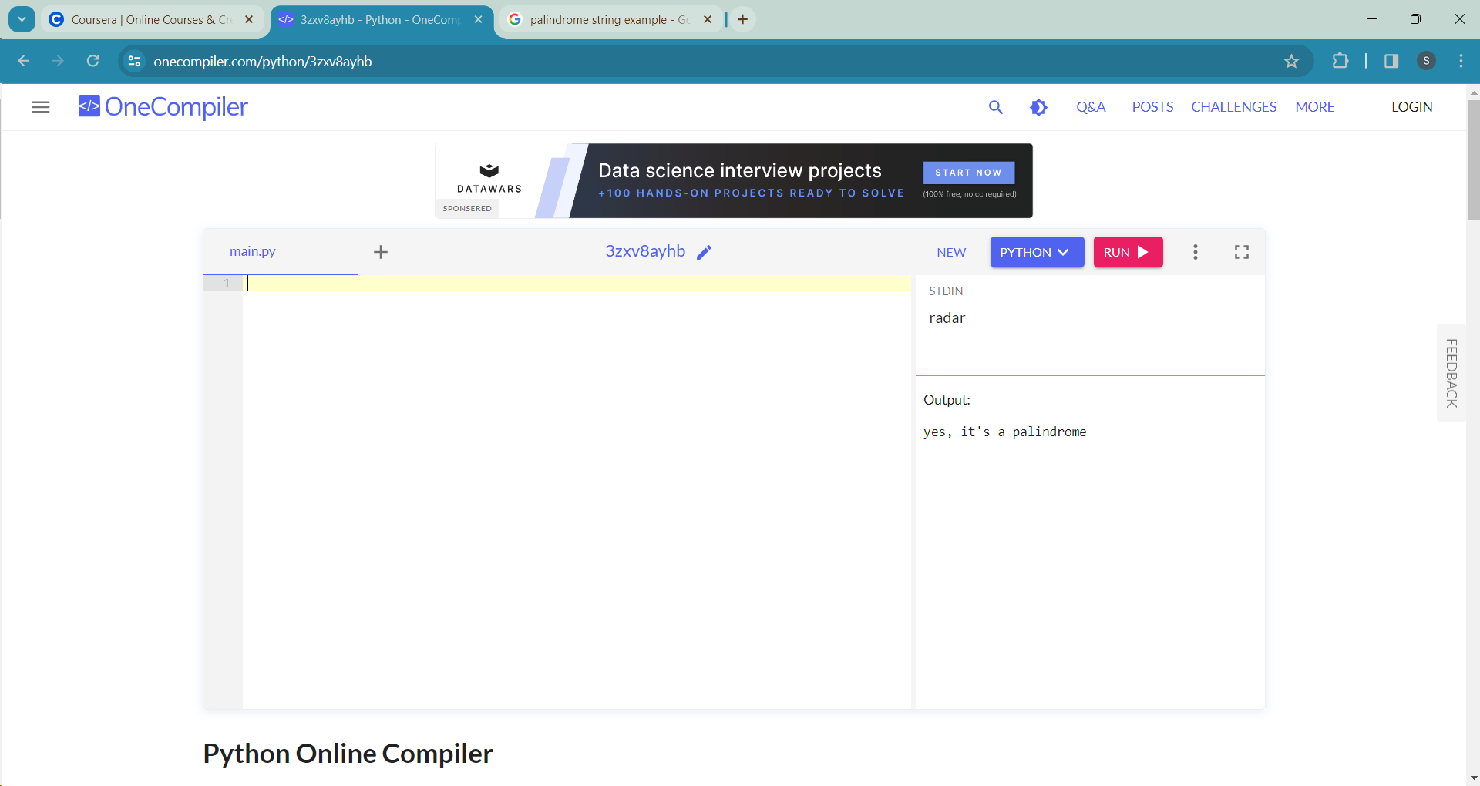

**#4.Create a function to reverse a given string**

x=input()

def rev_func(x):

return x[::-1]

txt=rev_func(x)

print(txt)

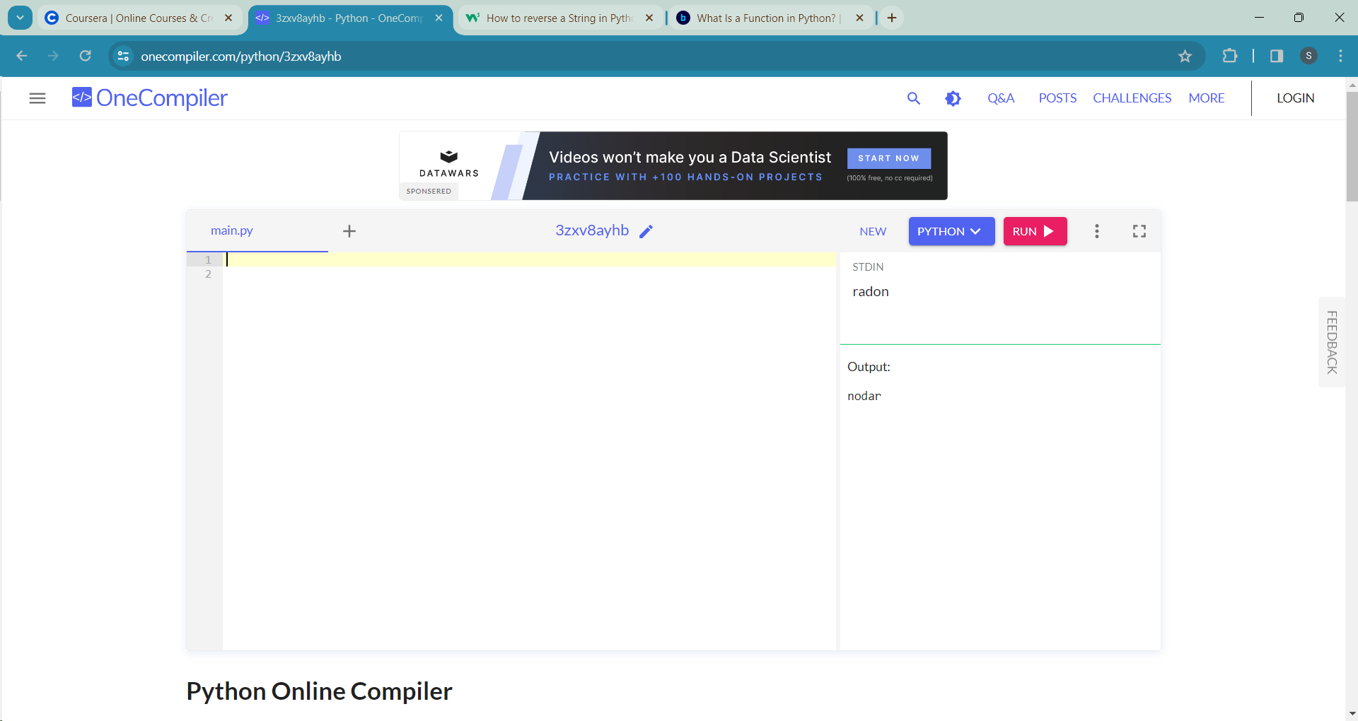

**#5.Given a list of names, concatenate them into a single string separated by spaces**

n= str(input())

a=str(input())

m=str(input())

e=str(input())

print(n+" "+a+" "+m+" "+e)

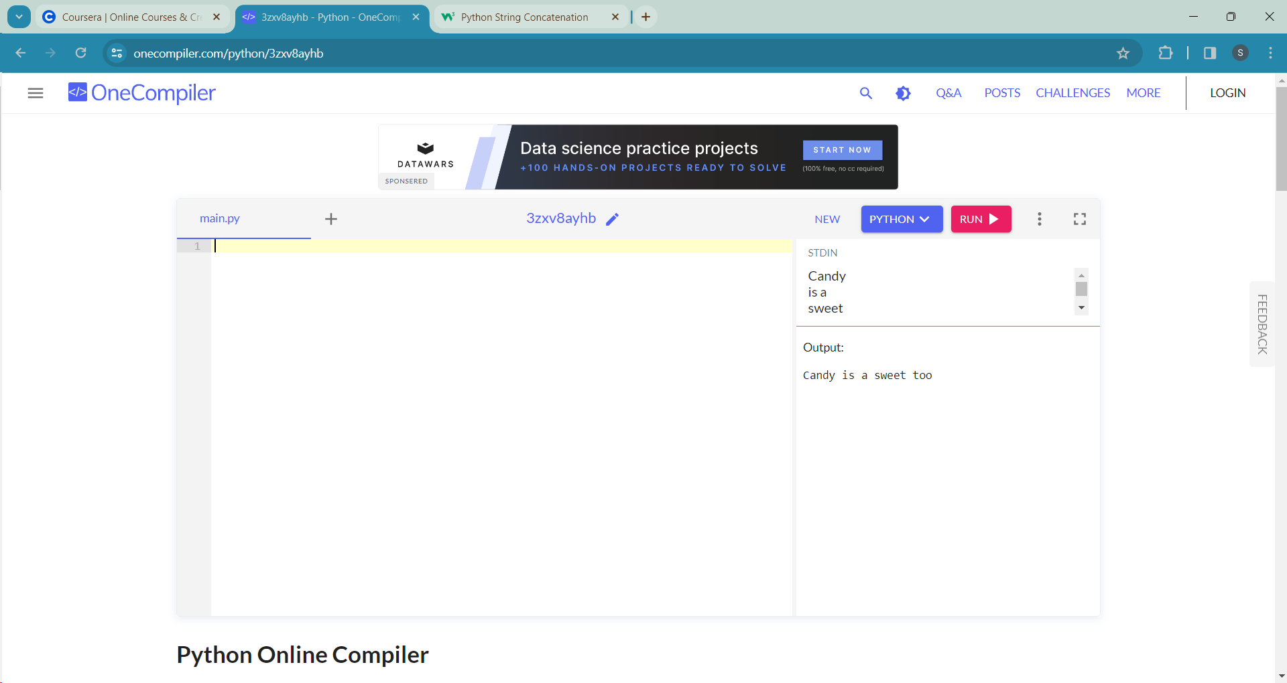

**#6.Write a Python program to check if a given string is a pangram (contains all letters of the alphabet)**

def is_panagram(str):

alphabet="abcdefghijklmnopqrstuvwxyz"

for char in alphabet:

if char not in str.lower():

return False

return True

panagram=str(input())

if is_panagram(panagram)==True:

print(panagram," is a panagram.")

else:

print("Not a panagram.")

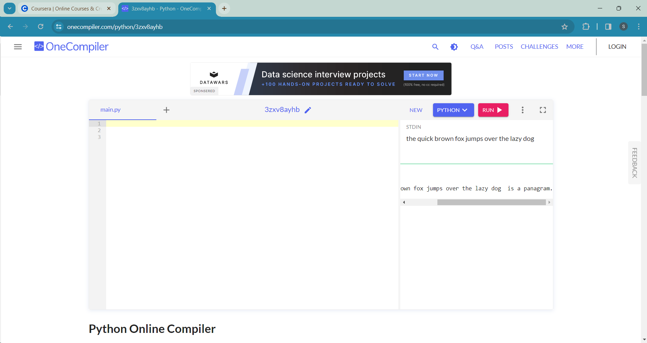

**#7.Calculate the area and circumference of a circle given its radius**

'''

area of a circle = pi*r^2

circumference=2*pi*r

r=radius

pi=3.14

'''

r= input())

radius=float(r)

area=3.14*radius*radius

circumference=2*3.14*radius

print("The area of circle is: ",area)

print("The circumference of circle is: ",circumference)

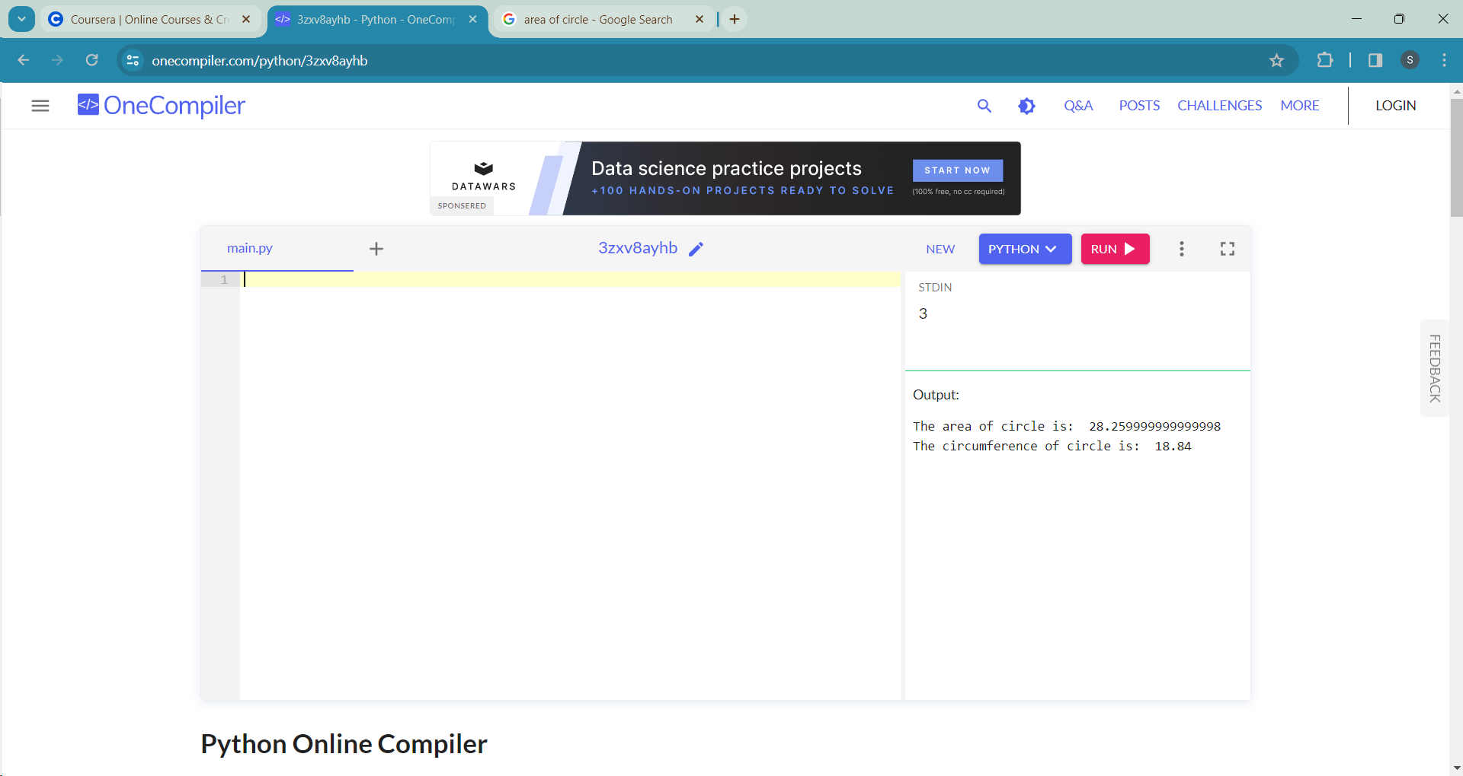

**#8.Implement a program that converts a given number of minutes into hours and minutes**

m=int(input())

hours=m/60

minutes=m%60

print("hours: ",hours)

print("minutes: ",minutes)

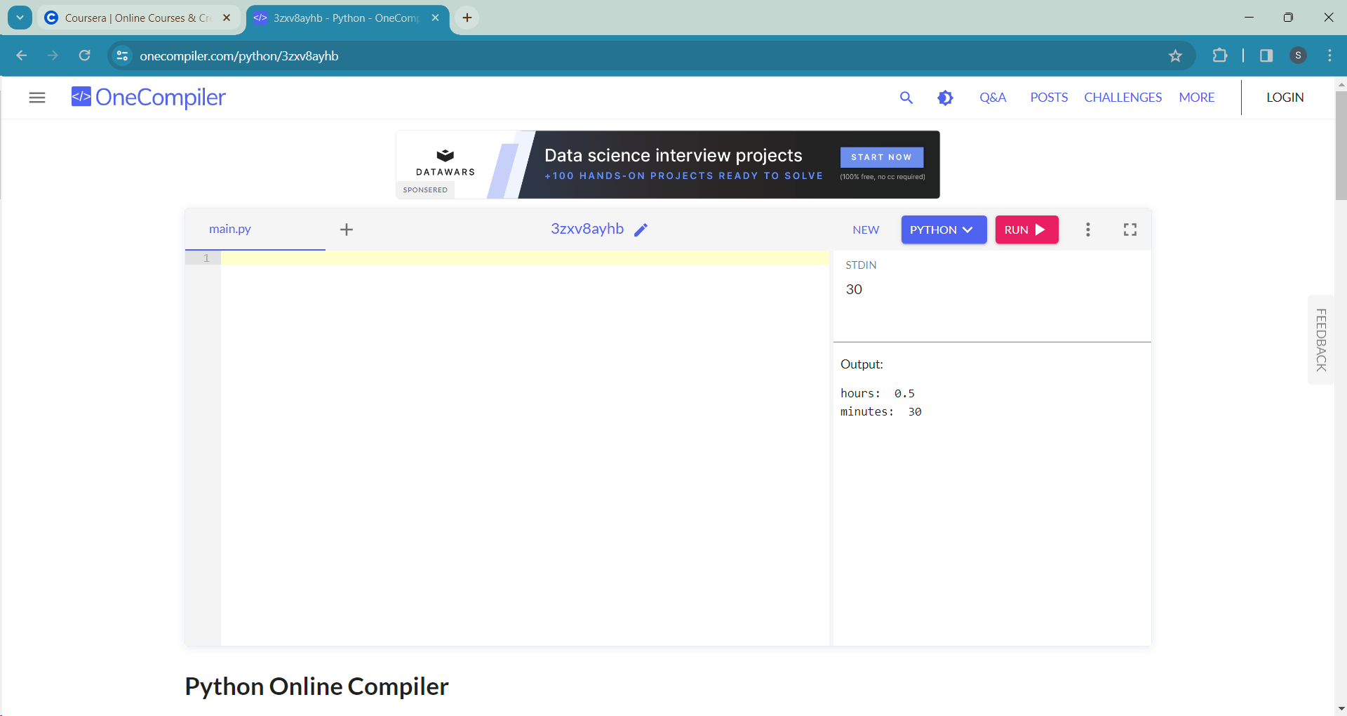

**#9.Create a function to count the number of vowels in a given string**

def vowel_count(str):

count =0

vowel=set('AEIOUaeiou')

for i in str:

if i in vowel:

count+=1

print('count: ',count)

string=str(input())

vowel_count(string)

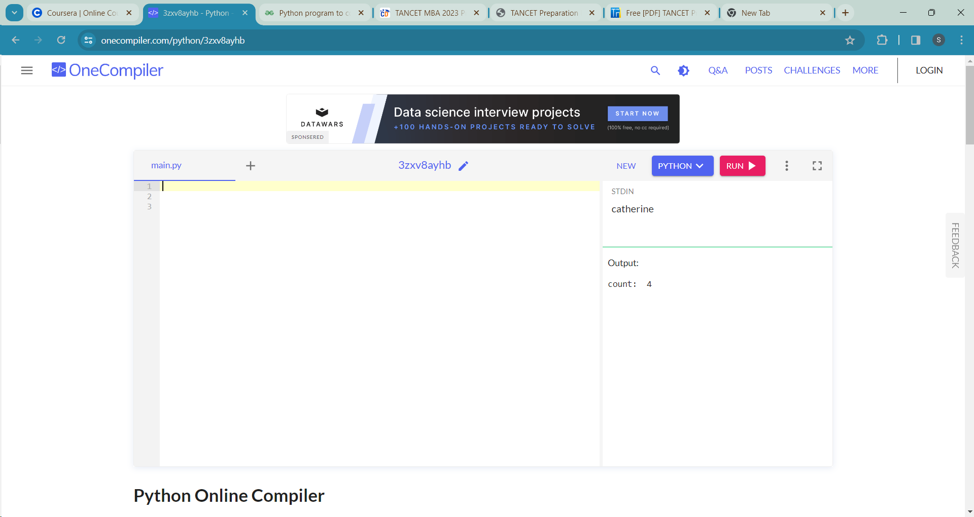

**#10. Write a program to check if a number is prime.**

n=int(input())

flag=0

if n==1:

print("Not prime")

for i in range(2,n):

if n%i==0:

flag=1

break

if flag:

print("Not prime")

else:

print("prime")

